Piyush Trivedi

Hunt for a sustainable borough to live in london

# **Section 1: Introduction**

London is a leading global city, demonstrating excellence in multiple areas including the arts, commerce, education, entertainment, research and development, fashion, finance, media, and tourism. Placed 2nd in the Global Cities Index Rank 2019 published by [Kearney](https://www.kearney.com/global-cities/2019), London accounts for 23% of the UK’s economic output with just 13% of the national population. It’s not only the world’s leading financial services centre but also Europe’s fastest growing technology hub and several of the world’s highest-ranking universities.

With its total population of London stood at just over 8 million, London is one of the most popular destinations for people all over the world. As per Annual population Survey from ONS, 36% of the Londoners are born outside of the UK with 41% comprising of Black and Minority Ethnicity. With regard to its ever-growing population, London has become the most ethnically diverse region in the UK with over 300 languages spoken.

# **Section 2: Business Problem**

London is certainly a land of opportunities for many people from all over the world and as they move to the city for job opportunities and education, they are poised with dilemma of where to find a place to Live. In this report I have tried to provide a solution for the same taking into consideration few basic criteria per borough and comparing them. The criteria considered are as follows –

* Rent Affordability - Borough wise Rent for past 2 years
* House Affordability - House price per earnings for 2019
* Quality of Education – Average Attainment of 8 score
* Crime Safety – Crime Incident per month per 1000 people 2
* Public Transport Accessibility Levels
* Types of Venues available

# **Section 3: Data**

## **3.1: Data Sources**

The Data Sources are as follows:

* London Boroughs List from Wikipedia Page
* ONS UK website –
  + London Rental Market [2020](https://www.ons.gov.uk/peoplepopulationandcommunity/housing/adhocs/12435privaterentalmarketinlondonoctober2019toseptember2020) and 2019 representing the
  + House prices to earning [data](https://data.london.gov.uk/dataset/index-private-housing-rental-prices-region)
  + GSCE result data for 2019
  + Borough Level Crime Data for 2019
  + Population Estimate for 2019
  + Public Transport Accessibility Levels data
* Geocoder to get Latitude Longitude data for each Borough
* Foursquare api to get venues in a radius of 1200m of each Borough

## **3.2: Data Cleaning**

The Inner/Outer Boroughs mapping is scrapped from Wikipedia site. The City of London is as independent entity and does not comes under any Borough classification but for the simplicity of classification I have categorized it as “Inner” Borough.

The statistics data collected from the ONS source are collected in dataframes and is refined further and merged into a single table with relevant field required for analysis per Borough. This data is normalized using minmax scaling to have values between 0 to 1 for better handling of data. The Rent per month, House price per earnings data, Crime Incidents per 1000 people is further inverted to and named as Rent Affordability, House Affordability, Crime Safety respectively.

Figure 3.1: Snap of Neighbourhood statistics data

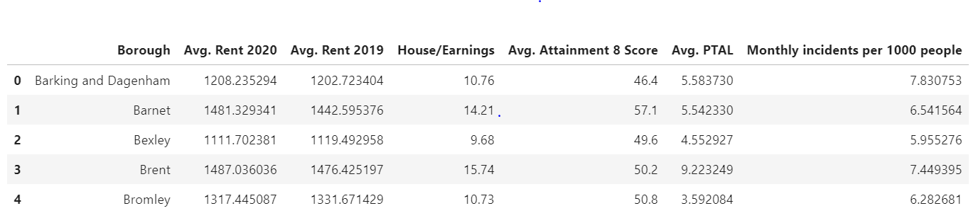

Figure 3.2: Snap of Normalized Neighbourhood statistics data

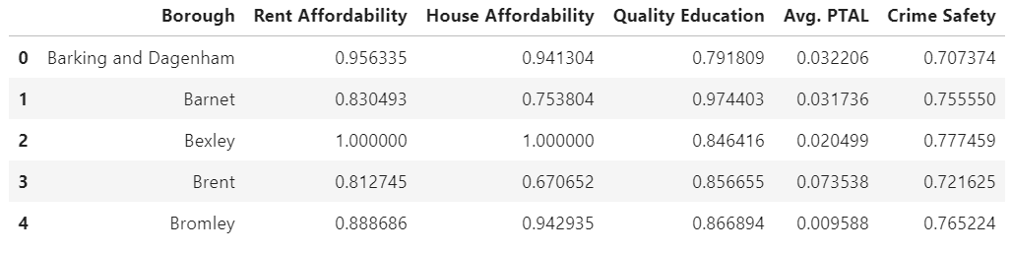

The Latitude and Longitude data for each Borough is obtained by using geocoder Library. In order to get venues data, Foursquare api is used to get first 100 most popular venues in a radius of 1200m of a given Borough Location. The venues category of the venues is at a granular level for example in case of restaurant we have Indian Restaurant, Chinese and so on. I have used Foursquare’s “Get Venue Categories” to classify these on a broader level of 10 Categories, so for example all sorts of restaurants are now classified under Food.

Figure 3.3: Snap of Broader Category for a given venue category

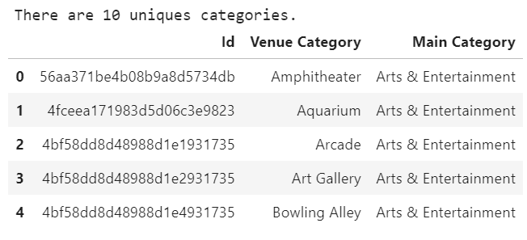

# **Section 4: Methodology**

## **4.1: Exploratory Data Analysis**

Once data is collected, cleaned and arrange in a meaningful way, basic charting is done to understand the statistics with respect to other Boroughs.

Figure 4.1: Average Rent per Borough

Figure 4.2: House Price per Earnings

Figure 4.3: Average Attainment 8 Score Per Student

Figure 4.3: Monthly Crime incidents per 1000 people

Figure 4.3: Neighbourhood Score

## **4.2: Cluster Analysis**

References –

1. <https://www.ons.gov.uk/peoplepopulationandcommunity/housing/adhocs/12435privaterentalmarketinlondonoctober2019toseptember2020>
2. <https://www.ons.gov.uk/peoplepopulationandcommunity/housing/adhocs/11100privaterentalmarketinlondonjanuary2019todecember2019>
3. <https://data.london.gov.uk/dataset/index-private-housing-rental-prices-region>
4. <https://data.london.gov.uk/dataset/gcse-results-by-borough>
5. <https://data.london.gov.uk/dataset/recorded_crime_summary>